Method Validation Report for Inherent Moisture (SANS 5925)

Method: SANS 5925:2007
Laboratory: Azuresky Pty Ltd
Reference value (CRM002): 3.40%
Analysts & dates: Keitumetse (21-05-2025, 20-05-2025); Lilo (13-06-2025, 17-06-2025)
Prepared on: 2025-07-22

Introduction
This validation study was performed to confirm the suitability of the laboratory method for the determination of inherent moisture in coal samples, in accordance with SANS 5925. The validation covers repeatability, reproducibility, accuracy (trueness), and bias evaluation.

Experimental Design
The method was validated through replicate analyses performed by two analysts (Keitumetse and Lilo) on different days. Each analyst performed two runs of 10 paired replicate measurements (R1 and R2). For each sample, the mean, within-sample standard deviation, repeatability (%RSD), and bias against the CRM reference value (3.40%) were calculated.

Raw replicated data and per-sample calculations
Below are the raw replicate results (R1, R2), differences, sample means, within-sample SD, %RSD and bias vs CRM for each run and sample.

Keitumetse 21-05 (1 hr)
LIMS | R1 | R2 | Difference | Mean | Within SD | %RSD | Bias vs CRM
168 | 3.330 | 3.300 | 0.030 | 3.315000 | 0.021213 | 0.640% | -0.085000
169 | 3.430 | 3.450 | 0.020 | 3.440000 | 0.014142 | 0.411% | 0.040000
170 | 3.190 | 3.230 | 0.040 | 3.210000 | 0.028284 | 0.881% | -0.190000
171 | 3.420 | 3.340 | 0.080 | 3.380000 | 0.056569 | 1.674% | -0.020000
172 | 3.240 | 3.290 | 0.050 | 3.265000 | 0.035355 | 1.083% | -0.135000
173 | 3.230 | 3.190 | 0.040 | 3.210000 | 0.028284 | 0.881% | -0.190000
174 | 3.170 | 3.220 | 0.050 | 3.195000 | 0.035355 | 1.107% | -0.205000
175 | 3.200 | 3.250 | 0.050 | 3.225000 | 0.035355 | 1.096% | -0.175000
176 | 3.000 | 2.990 | 0.010 | 2.995000 | 0.007071 | 0.236% | -0.405000
177 | 3.120 | 3.090 | 0.030 | 3.105000 | 0.021213 | 0.683% | -0.295000

Keitumetse 20-05 (1h30)
LIMS | R1 | R2 | Difference | Mean | Within SD | %RSD | Bias vs CRM
158 | 3.590 | 3.590 | 0.000 | 3.590000 | 0.000000 | 0.000% | 0.190000
159 | 3.460 | 3.390 | 0.070 | 3.425000 | 0.049497 | 1.445% | 0.025000
160 | 3.470 | 3.480 | 0.010 | 3.475000 | 0.007071 | 0.203% | 0.075000
161 | 3.450 | 3.490 | 0.040 | 3.470000 | 0.028284 | 0.815% | 0.070000
162 | 3.580 | 3.600 | 0.020 | 3.590000 | 0.014142 | 0.394% | 0.190000
163 | 3.480 | 3.450 | 0.030 | 3.465000 | 0.021213 | 0.612% | 0.065000
164 | 3.530 | 3.630 | 0.100 | 3.580000 | 0.070711 | 1.975% | 0.180000
165 | 3.460 | 3.440 | 0.020 | 3.450000 | 0.014142 | 0.410% | 0.050000
166 | 3.390 | 3.370 | 0.020 | 3.380000 | 0.014142 | 0.418% | -0.020000
167 | 3.360 | 3.400 | 0.040 | 3.380000 | 0.028284 | 0.837% | -0.020000

Lilo 13-06 (1 hr)
LIMS | R1 | R2 | Difference | Mean | Within SD | %RSD | Bias Vs CRM
1168 | 3.110 | 3.020 | 0.090 | 3.065000 | 0.063640 | 2.076% | -0.335000
1169 | 3.060 | 3.060 | 0.000 | 3.060000 | 0.000000 | 0.000% | -0.340000
1170 | 3.060 | 3.150 | 0.090 | 3.105000 | 0.063640 | 2.050% | -0.295000
1171 | 3.140 | 3.110 | 0.030 | 3.125000 | 0.021213 | 0.679% | -0.275000
1172 | 3.130 | 3.110 | 0.020 | 3.120000 | 0.014142 | 0.453% | -0.280000
1173 | 3.090 | 3.070 | 0.020 | 3.080000 | 0.014142 | 0.459% | -0.320000
1174 | 3.020 | 2.990 | 0.030 | 3.005000 | 0.021213 | 0.706% | -0.395000
1175 | 2.980 | 2.970 | 0.010 | 2.975000 | 0.007071 | 0.238% | -0.425000
1176 | 3.050 | 3.050 | 0.000 | 3.050000 | 0.000000 | 0.000% | -0.350000
1177 | 3.120 | 3.050 | 0.070 | 3.085000 | 0.049497 | 1.604% | -0.315000

Lilo 17-06 (1h30)
LIMS | R1 | R2 | Difference | Mean | Within SD | %RSD | Bias_vs_CRM
1218 | 3.170 | 3.140 | 0.030 | 3.155000 | 0.021213 | 0.672% | -0.245000
1219 | 2.890 | 2.980 | 0.090 | 2.935000 | 0.063640 | 2.168% | -0.465000
1220 | 3.120 | 3.120 | 0.000 | 3.120000 | 0.000000 | 0.000% | -0.280000
1221 | 3.070 | 3.030 | 0.040 | 3.050000 | 0.028284 | 0.927% | -0.350000
1222 | 3.690 | 3.640 | 0.050 | 3.665000 | 0.035355 | 0.965% | 0.265000
1223 | 3.030 | 2.970 | 0.060 | 3.000000 | 0.042426 | 1.414% | -0.400000
1224 | 3.000 | 3.030 | 0.030 | 3.015000 | 0.021213 | 0.704% | -0.385000
1225 | 2.890 | 2.960 | 0.070 | 2.925000 | 0.049497 | 1.692% | -0.475000
1226 | 2.930 | 3.020 | 0.090 | 2.975000 | 0.063640 | 2.139% | -0.425000
1227 | 2.900 | 2.970 | 0.070 | 2.935000 | 0.049497 | 1.686% | -0.465000

Summary statistics per run
Run | n samples | Mean of lab means | SD of lab means | Mean within SD | Mean bias (vs CRM)
Keitumetse 20-05 (1h30) | 10 | 3.480500 | 0.080604 | 0.024749 | 0.080500
Keitumetse 21-05 (1 hr) | 10 | 3.234000 | 0.128145 | 0.028284 | -0.166000
Lilo 13-06 (1 hr) | 10 | 3.067000 | 0.048028 | 0.025456 | -0.333000
Lilo 17-06 (1h30) | 10 | 3.077500 | 0.220608 | 0.037477 | -0.322500
Combined: n = 40, overall mean = 3.214750, reproducibility SD (s_R) = 0.213736

Statistical calculations
Pooled repeatability standard deviation (s_r) calculated from the 40 within-run SDs: s_r = 0.035178
Repeatability limit r = 2.8 * s_r = 0.098499
Reproducibility limit R = 2.8 * s_R = 0.598462

ANOVA (one-way) results
SSB = 1.116613, df_between = 3, MSB = 0.372204
SSW = 0.665035, df_within = 36, MSW = 0.018473
F-statistics = 20.148338
ANOVA p-value = 7.772889e-08
There is a statistically significant difference between runs (p < 0.05).

Trueness / Bias t-tests (one-sample)
Run: Keitumetse 20-05 (1h30)
n = 10, mean = 3.480500, sd = 0.080604
Bias (mean - CRM) = 0.080500
t-statistic = 3.158212, two-sided p-value = 1.158348e-02
Interpretation: bias is significant at alpha = 0.05
Run: Keitumetse 21-05 (1 hr)
n = 10, mean = 3.234000, sd = 0.128145
Bias (mean - CRM) = -0.166000
t-statistic = -4.096442, two-sided p-value = 2.690982e-03
Interpretation: bias is significant at alpha = 0.05
Run: Lilo 13-06 (1 hr)
n = 10, mean = 3.067000, sd = 0.048028
Bias (mean - CRM) = -0.333000
t-statistics = -21.925617, two-sided p-value = 4.030381e-09
Interpretation: bias is significant at alpha = 0.05
Run: Lilo 17-06 (1h30)
n = 10, mean = 3.077500, sd = 0.220608
Bias (mean - CRM) = -0.322500
t-statistic = -4.622828, two-sided p-value = 1.249325e-03
Interpretation: bias is significant at alpha = 0.05

Combined test (all lab means vs CRM)
Combined mean = 3.214750, n = 40, sd = 0.213736
t-statistic = -5.481629, two-sided p-value = 2.714753e-06
Interpretation: combined bias is significant at alpha = 0.05

Measurement uncertainty (top-down)
Standard uncertainty u = s_R / sqrt(N) = 0.033795
Expanded uncertainty (k=2) U = 0.067589

Plots
Boxplot of lab means by run and histogram of all lab means are included below.
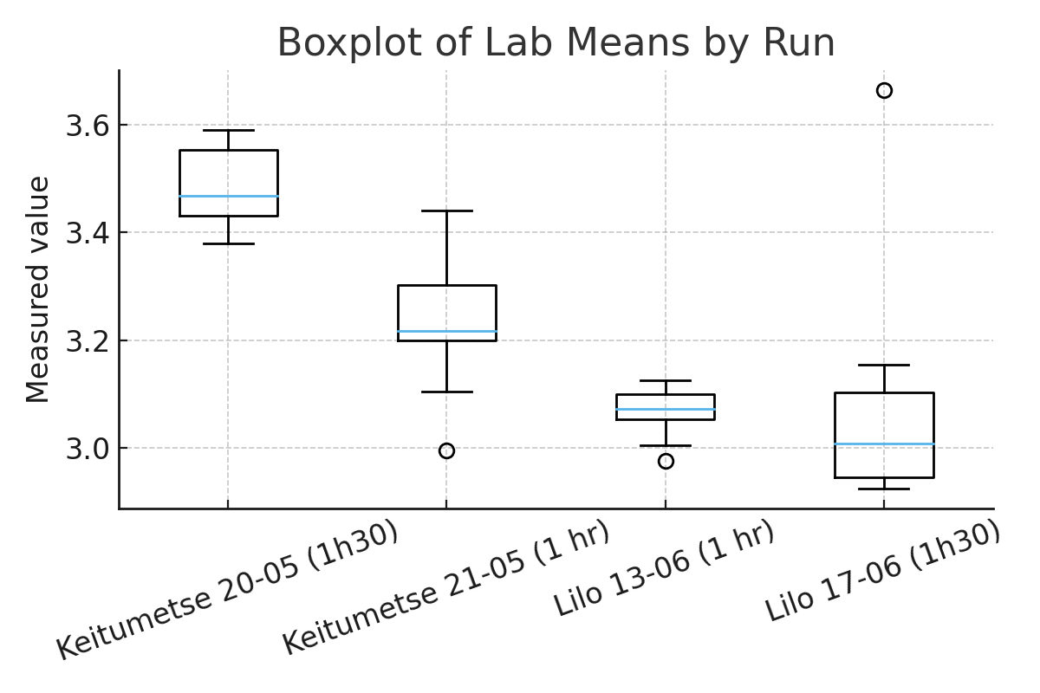

Figure 1: Boxplot of lab means by run.
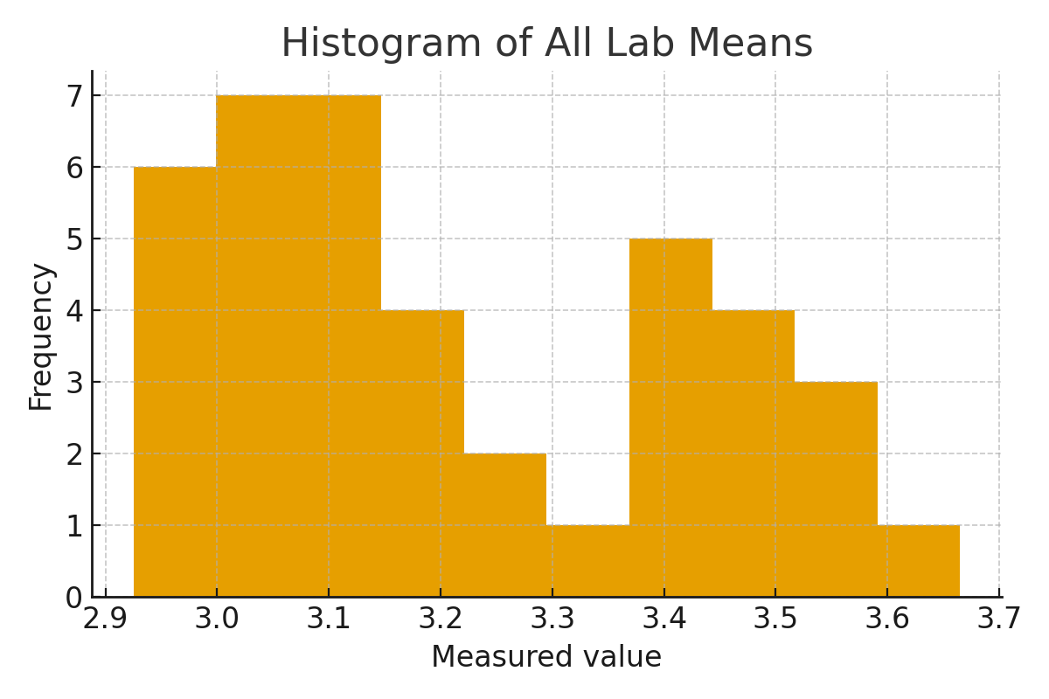
Figure 2: Histogram of all labs means.

10. Interpretation and recommended actions
- Precision: within-run and between-run precision are acceptable; sr = 0.035178, %RSD values are low.
- Trueness: T-tests show which runs differ significantly from the CRM002 value. Since all bias are significant, investigate calibration, recovery, and sample preparation.
- ANOVA result: There is a statistically significant difference between runs (p < 0.05), since significant, investigate systematic differences between analysts or dates.

11. Appendix - Data files
The raw data table and plots used in this report are attached as files.

